

CT问卷网

Review meeting

Review meeting
Date | 2014.7.10 | Place | 317
Comparison actual with planning for this iteration
Story ID | task | people | Estimated | Actual
4 | modify the created questionnaire,function design and test | 王成真、闪硕 | 8 | 8
5 | Release the questionnaire, function design and test | 赵付涛、黄海亮 | 5 | 5
6 | limit of the times a person could submit, function design and test | 李天宇 | 4 | 4
7 | set access permissions, function design and test. | 付明霞、赵付涛 | 3 | 3
8 | end/reopen a questionnaire, function design and test. | 闪硕 | 3 | 3
9 | analyze the survey, function design and test. | 吕志宏、王成真 | 8 | 8
10 | generate and release the analysis report,UI design and test | 吕志宏、王成真 | 4 | 4
14 | design different way to access the URL of a questionnaire | 葛理奇 | 6 | 6
15 | visit the questionnaire he/she had filled before,function and UI design and test | 黄海亮、闪硕 | 6 | 6
16 | Set the questionnaire’s status, function design and test | 闪硕 | 5 | 5
17 | visit the questionnaire he/she had created before, function and UI design and test | 闪硕 | 6 | 6
18 | Design the UI for paticipant to fill in and submit. | 付明霞、黄海亮、李明远 | 6 | 6
Burning down:
We have finished all the user stories and all the estimated points burns down on time.
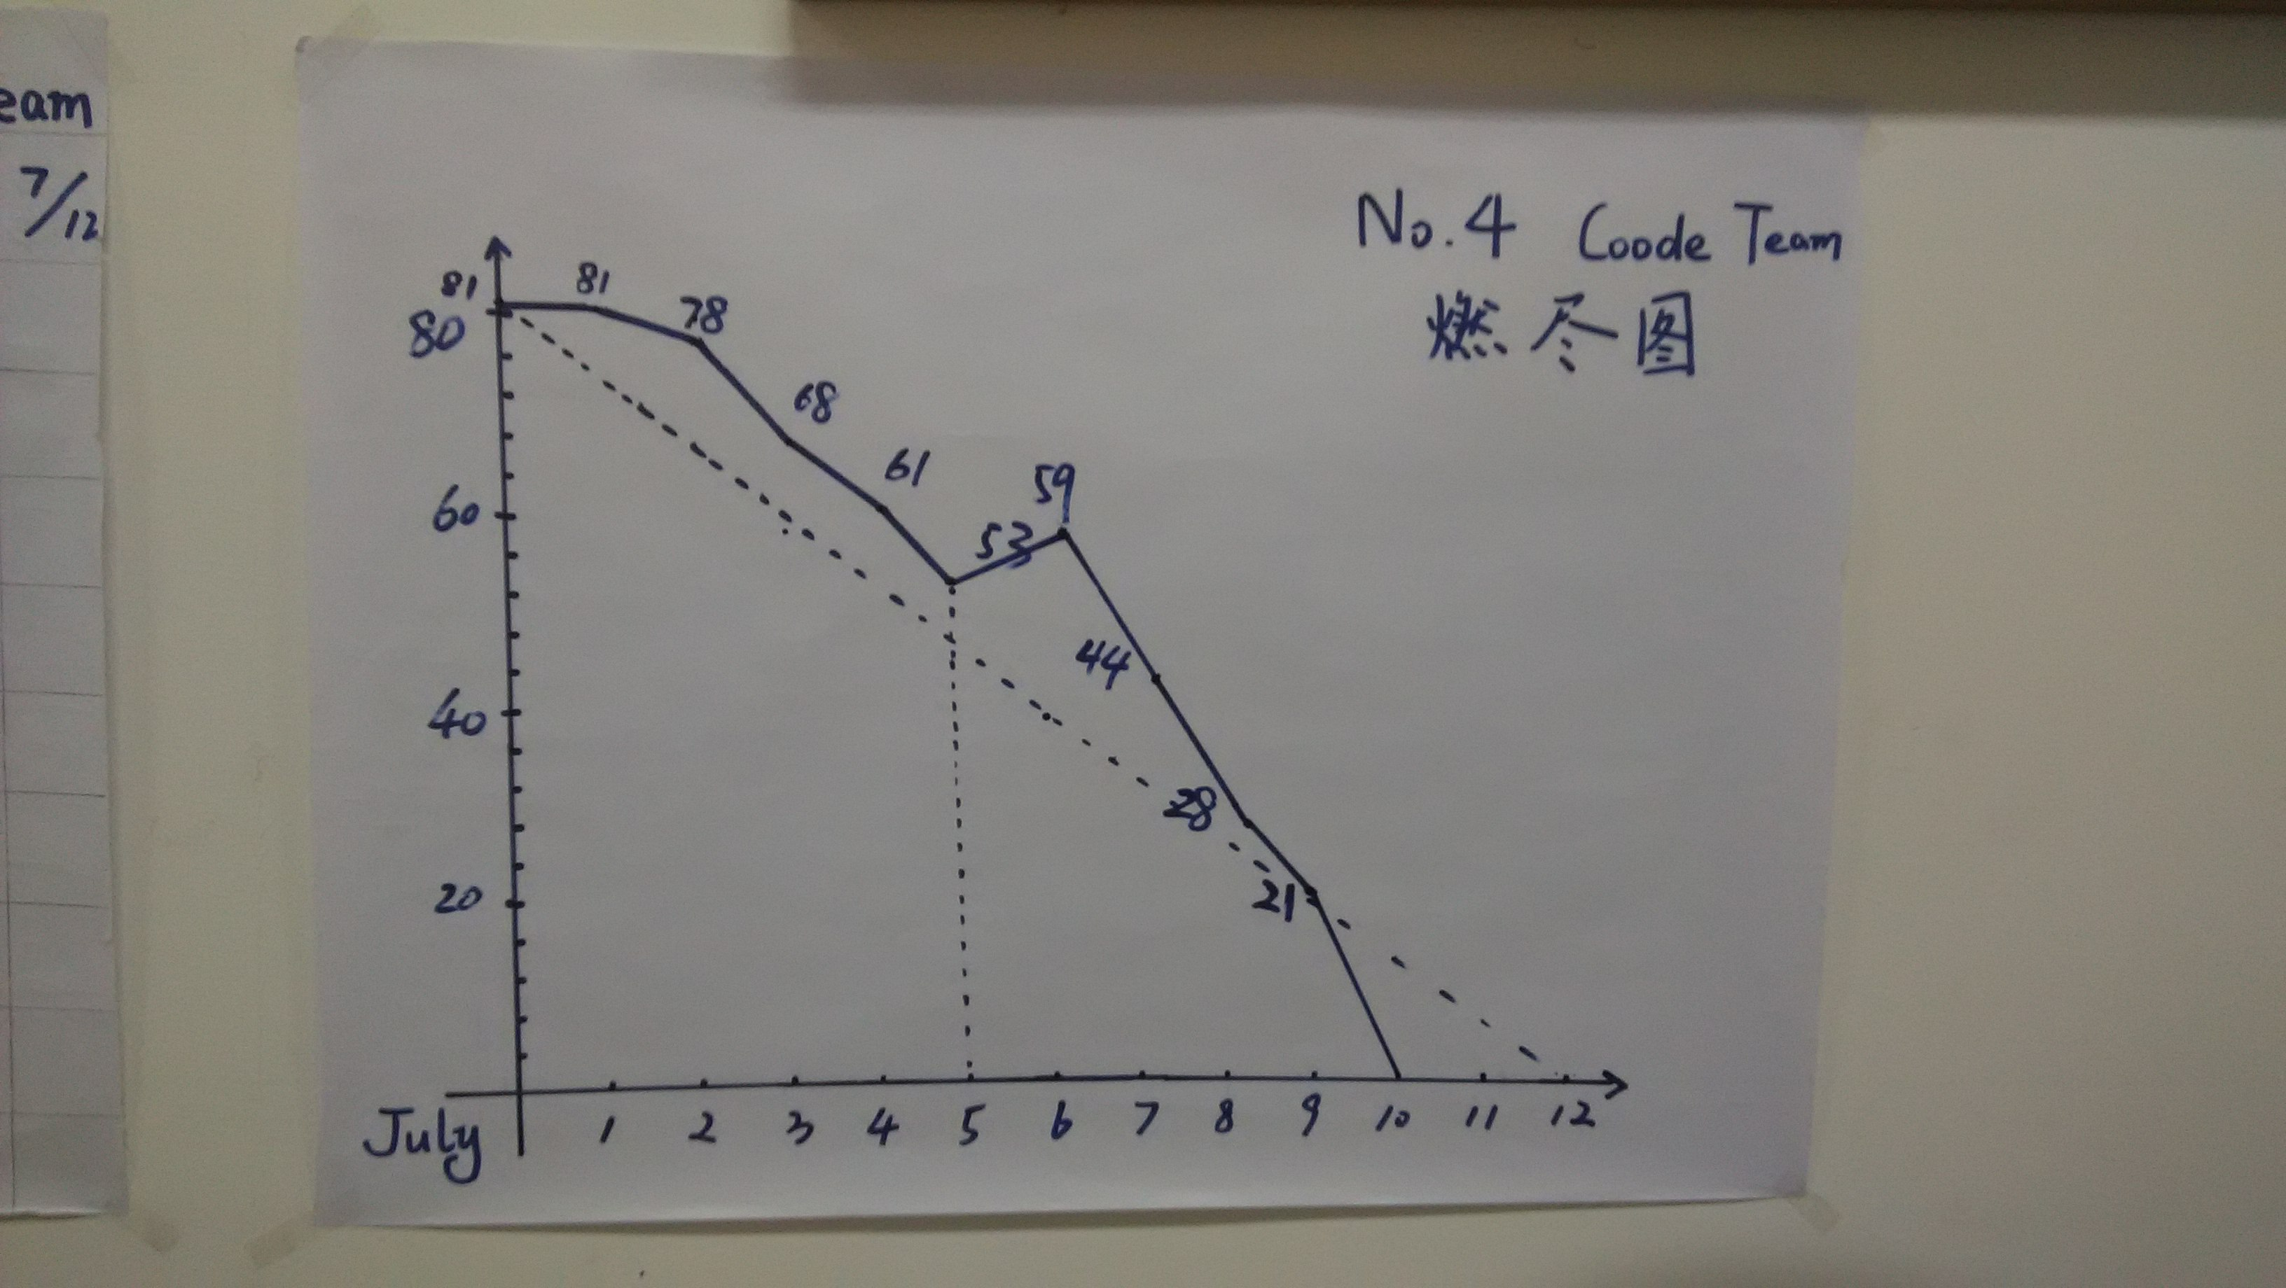

Good things:
Our user stories fullfil the demands of customers and are proved excellent;
Untied management ensures our effictive and efficent efforts;
Personal attitudes added enough communication lead to our success.
Need to improve things:
Communication is still not enough, contributing to ignored problems;
Our preparation is not so perfect at the beginning that much time was wasted;
Some user stories need to be combined or cut apart .
Ideas!
Some extra user demands should be added so that the web site seems to be more reasonable.

The adjusted planning for the next iteration

Peer assessment
L1（not exceeding 15%）:4、10
L2(not exceeding 25%）:2、3、8
L3: 1、5、6、7、9、11、12、13、14、15
L4:
L5:

By the way, I think our Feeling Board is the most vivid, it’s owe to Li Mingyuan. He made it by heart. Look at this picture:
